**Name:** Alec Mabhiza Chirawu

**Student ID:** M202161029

**Course:** Digital communications

**Assignment 1:** Summarizing 4 classes

**Why we need communication systems:**

1. To maximize transmission rate.
2. To maximize system utilization.
3. To minimize bit error rate.
4. To minimize required systems bandwidth.
5. To minimize system complexity.
6. To minimize required power.

**Main concept in communication systems:**

Source coding reduce number of symbols in a message and recover the original source information in video, images and languages.

Transmitter if for data transmission and modulation is the main key for maching the channel medium.

Channel coding for translate information bits to transmitter data symbols.

Receiver

Recipient

**Mathematical models for communication channels:**

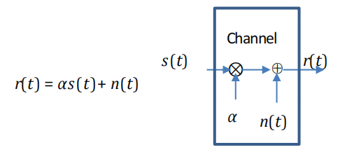

- In this system model s(t) is the source which goes through the channel r(t) is the received signal.

- N(t) is the additive noise.

- alpha is the attenuation factor.

**Linear filter channel with additive noise:**

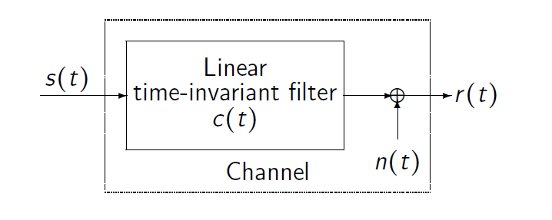

Since noise is everywhere this filter channel is highly required.

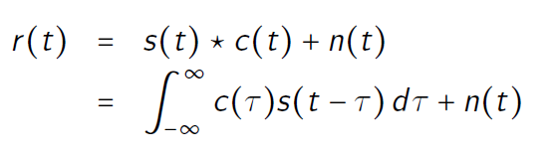

- Since this is a convolution we will have to multiply s(t) and c(t).

-and we integrate the function in a certain given period.

* Incase its not easy to filter then this function is used.

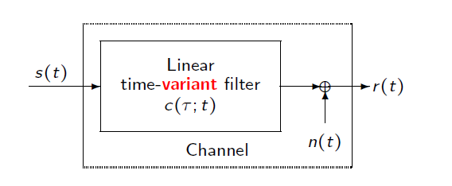

For all three factors the equation are given by:

Linear Time-Invariant Filter Channel (AWGN)

*r* (*t) = s(t)* ∗ *c(t)+ n(t)*

Linear Time-Variant Filter Channel

*r*(*t*) = *s*(*t*) ∗c(t;r) + *n*(*t*)

Multipath propagation

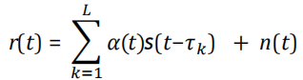

**Bandpass and lowpass signal presentation**

- In reality we transmit real signal but in mathematical world its not necessary, so on bandpass signal it means we have moved our signal to higher level menaing its read to be send.

In lowpass signal it is band limited but its not the same signal as bandpass.

We only take the positive part because its symmetric.

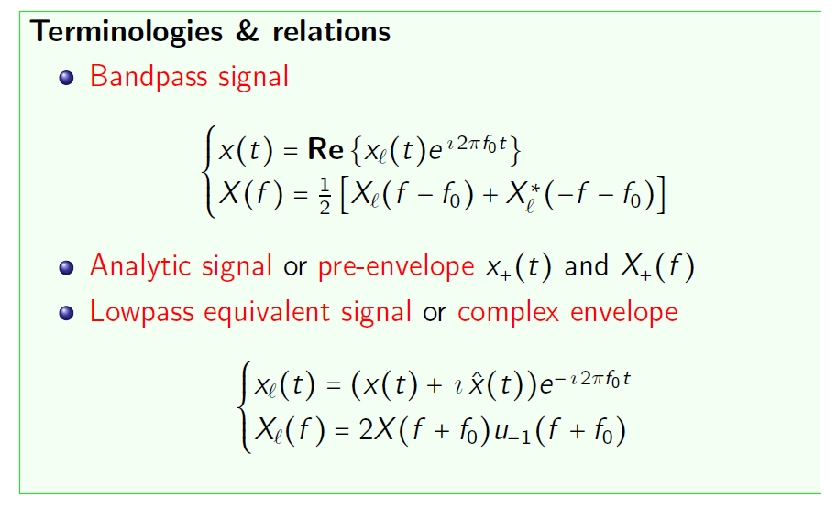

From the terminologies and relations above , in reality we only transmit x(t). bandpass signal.

For lowpass we uses modulation and for bandpass we use demodulation.

For Parseval’s Theorem Fc is far larger than the bandwidth and the equation of Xf will not overlap.

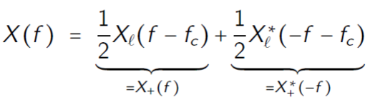

- In case they overlap then the project of them is 0.



From this we can conclude that:

- Bandpass signal is just a signal containing a band of frequencies not adjacent to zero frequency, such as a signal that comes out of a bandpass filter.

- Lowpass filter is a circuit that only passes signals below its cutoff frequency while attenuating all signals above it. It is the complement of a high-pass filter, which only passes signals above its cutoff frequency and attenuates all signals below it.